Parameters that depend on Arity and Chunk Size...

1. Merkle Tree Height (H):
= log(256MB/Chunk Size) base (Arity).
2. Merkle Proof Size:
= Height * (Arity -1) * 32B (Assuming SHA256)
3. Merkle Tree Overhead:
proportional to 1/(k-1)

Proof
Let:
- N = Total number of leaves
- k = Arity
- I = Internal nodes (non-leaf nodes)
- S= The size of a single hash (32B)
Overhead=I×S
Every internal node has k children which implies total number of children = I×k
Total number of nodes excluding the main parent = (N+I) – 1
Equating the above equations we get I to be proportional to 1/(k-1).

4. Update Cost:
Proportional to the amount of data that needs to be re hashed.
That is chunk size + (Proof Size) * 32B

Graphs:
Merkle Tree Height:
graph shows the depth of the tree in levels. A shallower tree is better because it requires fewer hashing operations to verify a data block
Merkle Proof Size:
This graph represents the amount of data (sibling hashes) that needs to be fetched from memory for each integrity verification
Merkle Tree Overhead
This heatmap shows the total memory (in MB) required to store all the intermediate hash nodes. This is a factor for your memory usage outside the chip.
Update Cost
This graph represents the total computational workload for a single data update

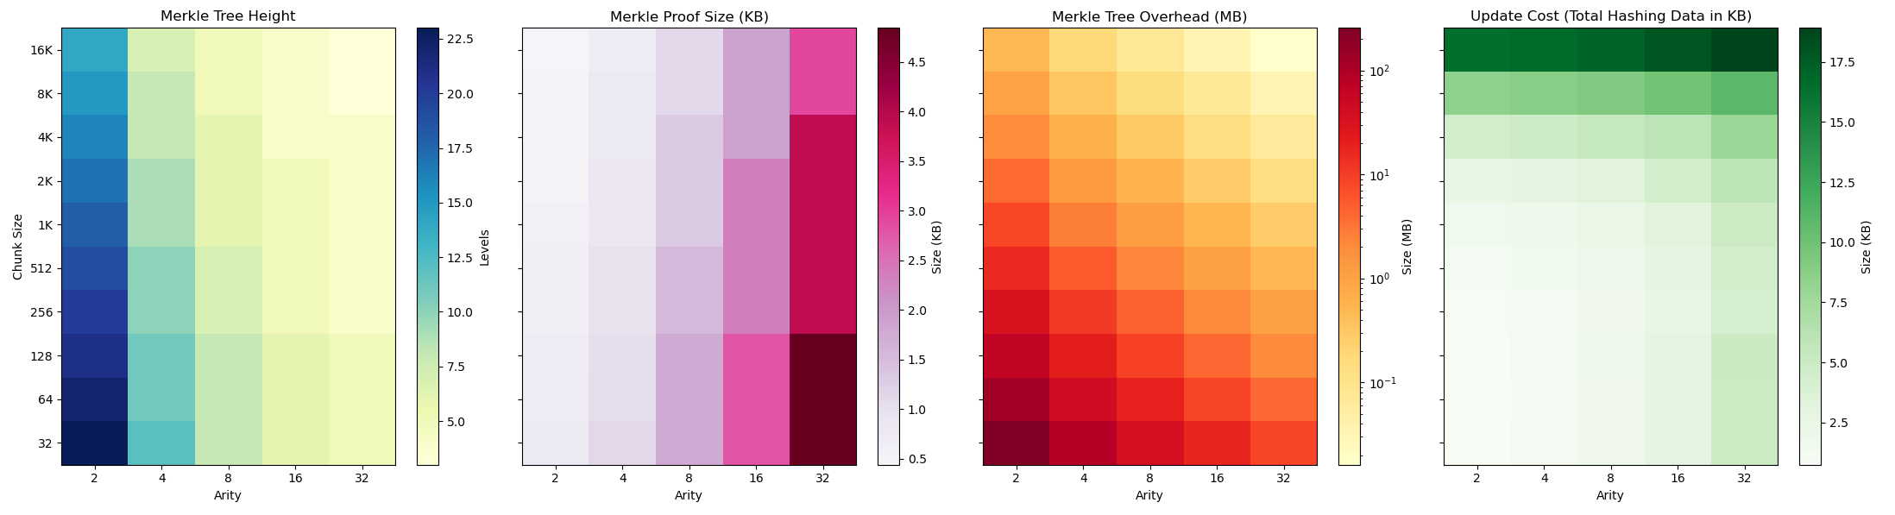
If a Chunk Size of 4KB is fixed... Comparing hash time and fetch time between Arity 8 & 16

Metric | Arity 8 | Arity 16
Tree Height | 6 levels | 4 levels
Path Hashing | 6×4 blocks = 24 blocks | 4×8 blocks = 32 blocks
Hashes to Fetch | 6×(8−1)=42 hashes | 4×(16−1)=60 hashes

So Arity taken should be 8.

